
QUALITY ALERT

Customer: WIN-DOR Date: July 28, 2017
Die: 5254 Colour: ALL
Type of Complaint: Customer Complaint

Q.A # Q.I.R # CUSTOMER NCR #

Description: Customer Complaint due gap being too small to fit through the punch
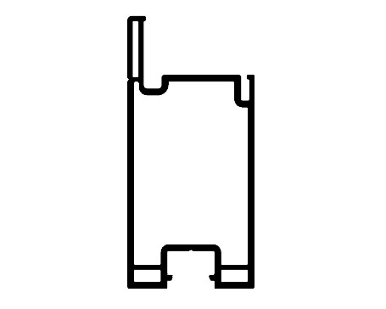
Piece inside Punch
Horn Goes through here
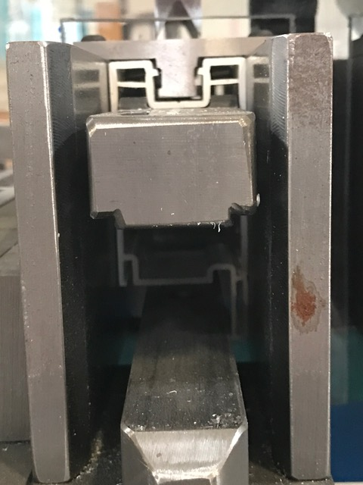
MINIMUM OF 0.365” WIDE
MINIMUM OF 0.170”
HIGH

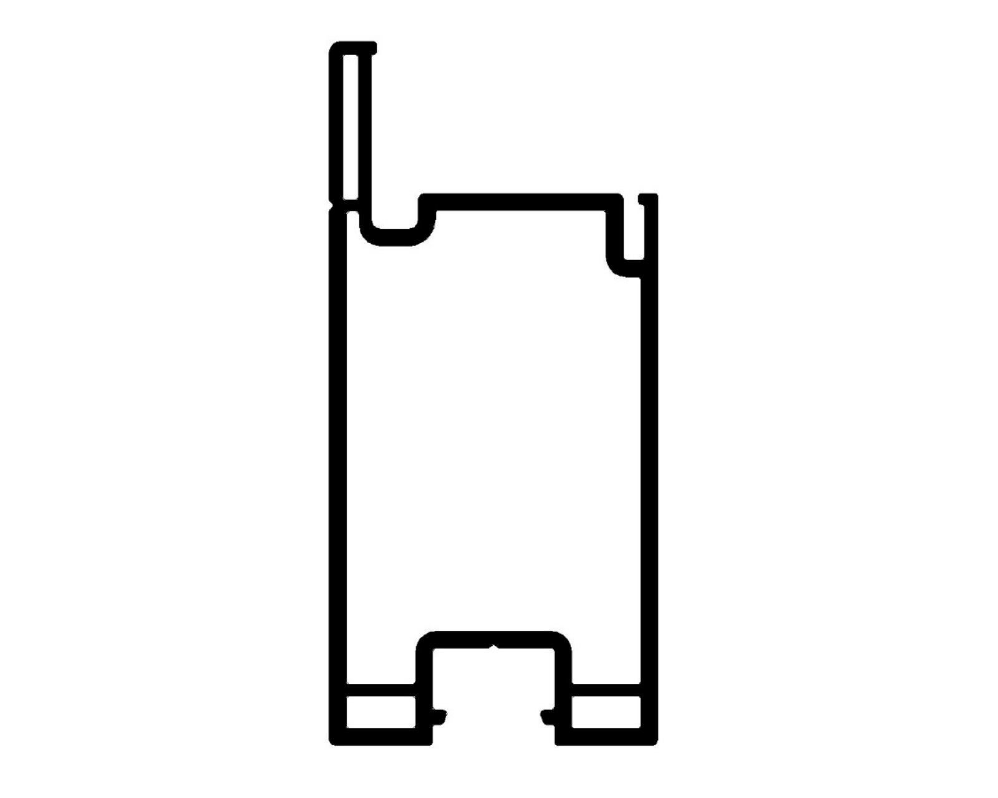

0.175”
0.370”

BY SIGNING BELOW, YOU ACKNOWLEDGE THE PROBLEM ABOVE AND AGREE TO MONITOR THIS ISSUE IN FUTURE PRODUCTION RUNS.
DAY SHIFT |  | AFTERNOON SHIFT |  | NIGHT SHIFT
NAME | SIGNATURE | NAME | SIGNATURE | NAME | SIGNATURE

